**Performance Testing using k6 + influx DB + Grafana without Docker**

1. Install influxDB (brew install influxDB)
2. Install Grafana (brew install Grafana)
3. Install K6 (brew install k6)
4. Start Grafana

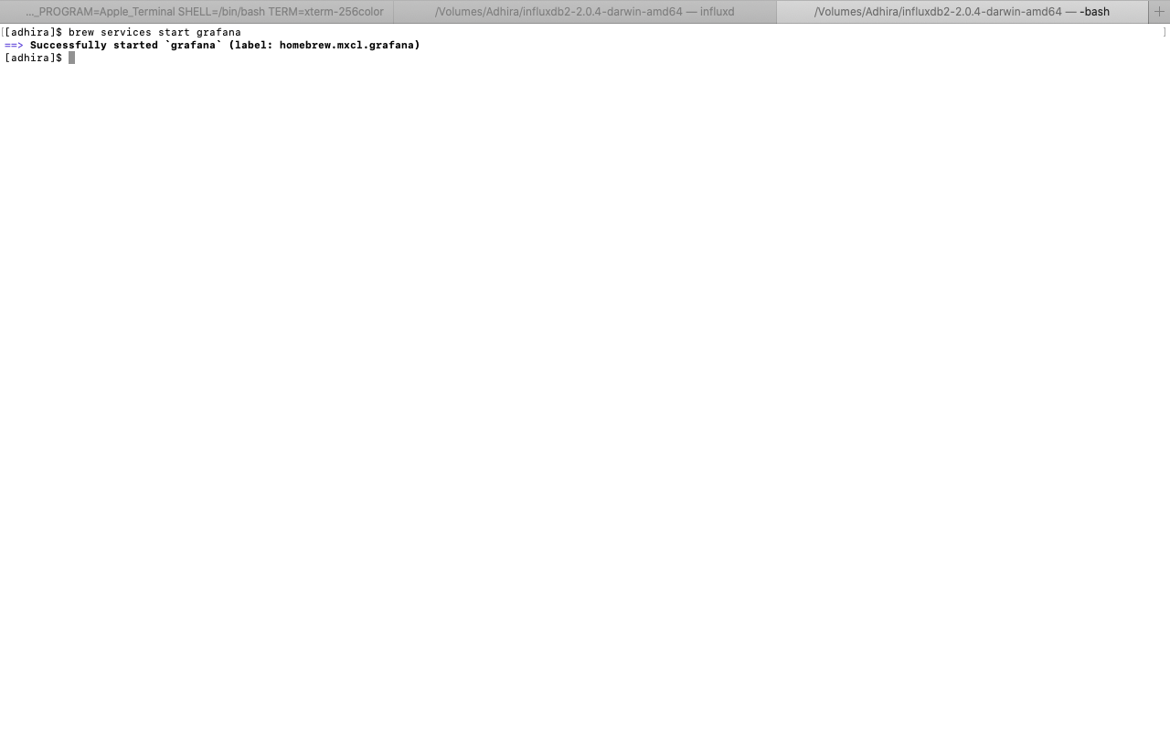

1. Start influxDB

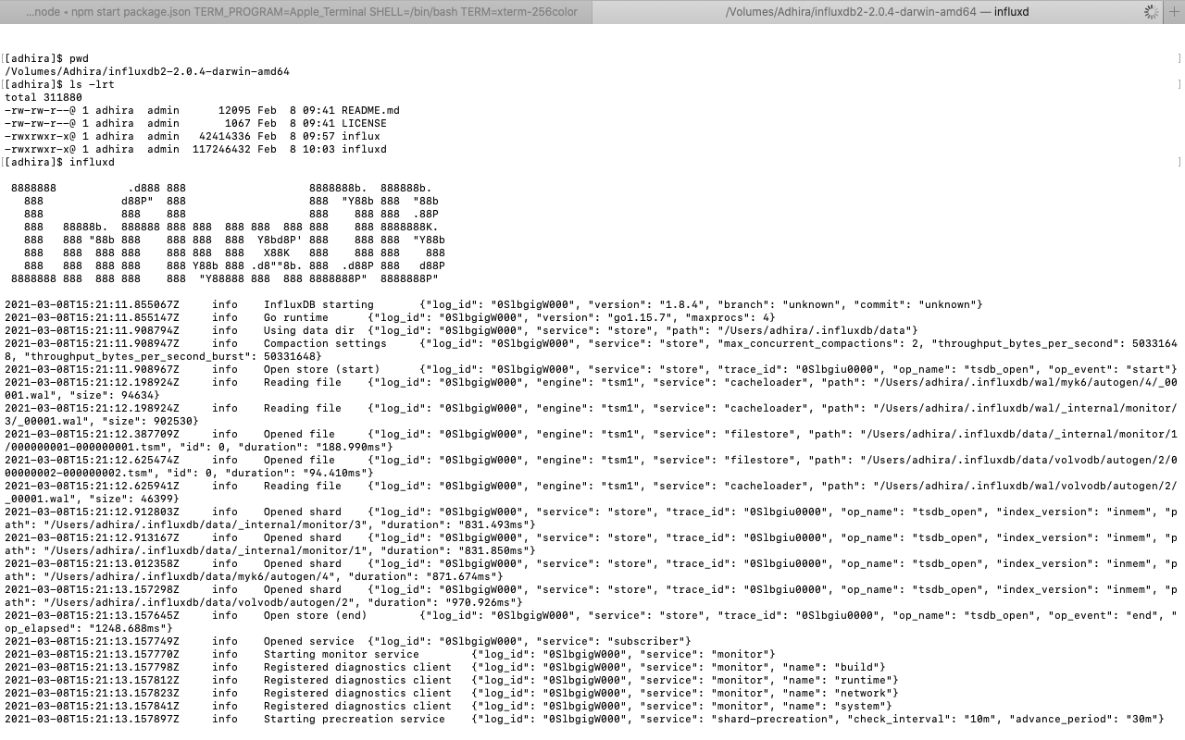

1. Open the browser and hit the URL <http://localhost:8086/>.
2. Create the datasource

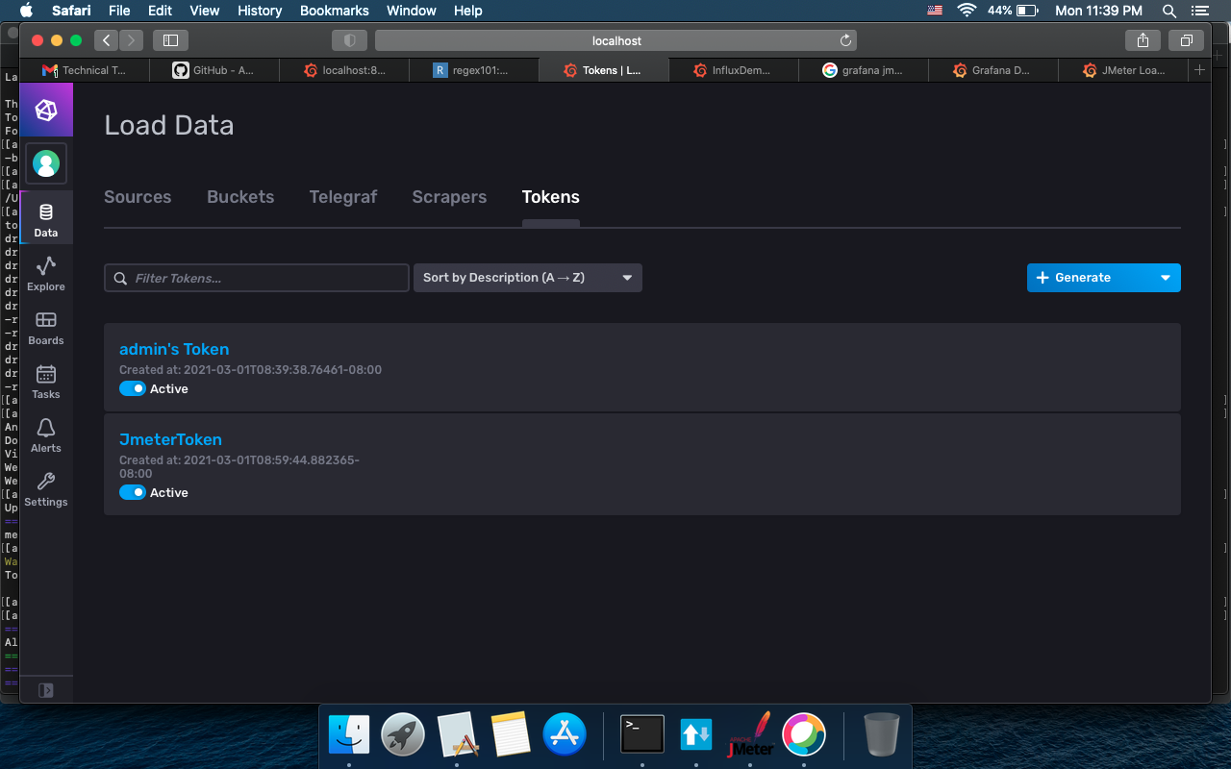

1. Open the browser and hit the URL <http://localhost:3000/>.

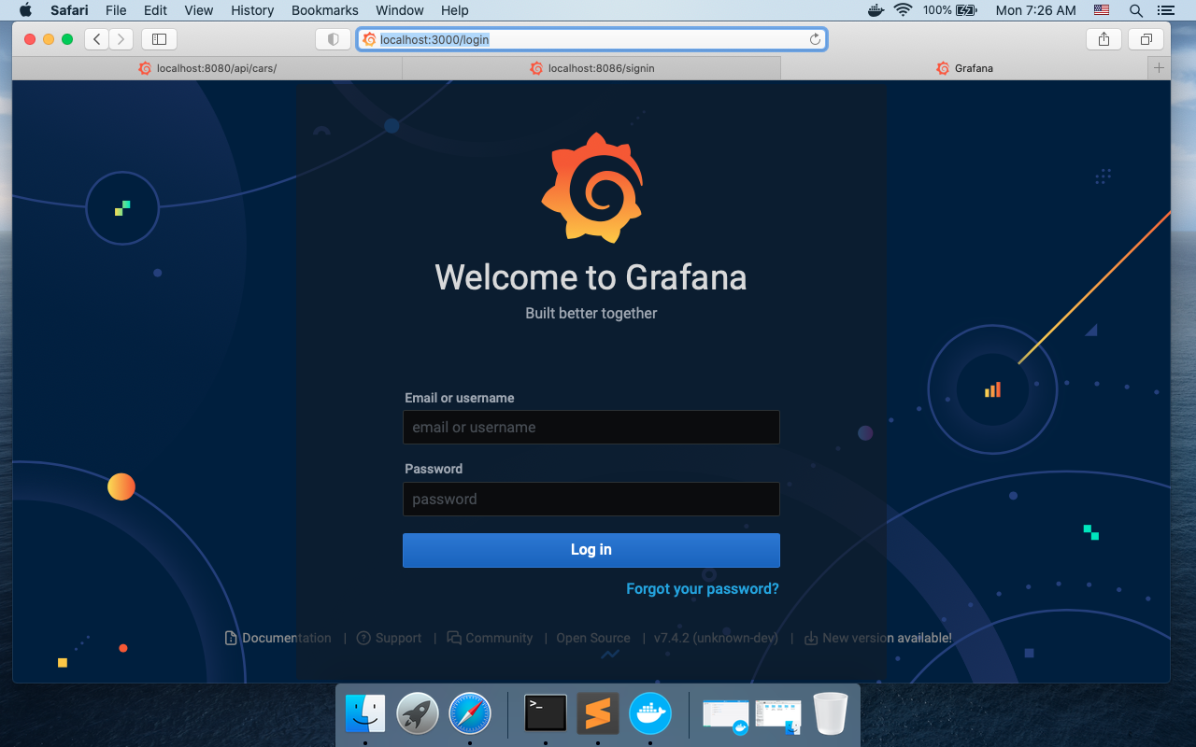

1. Login into Grafana (use admin/admin)

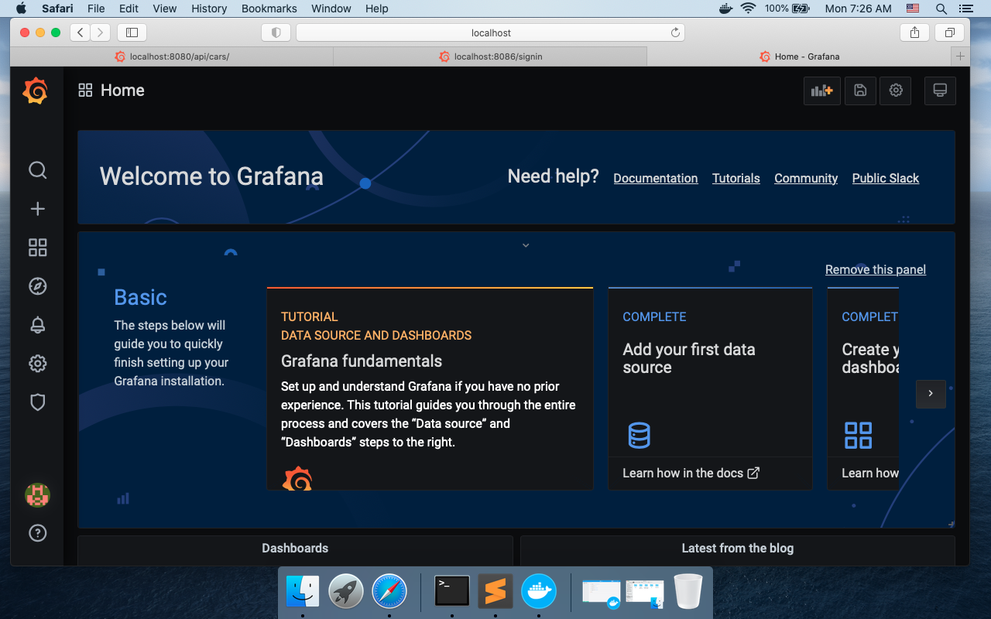

1. Validate the datasource created in influxdb

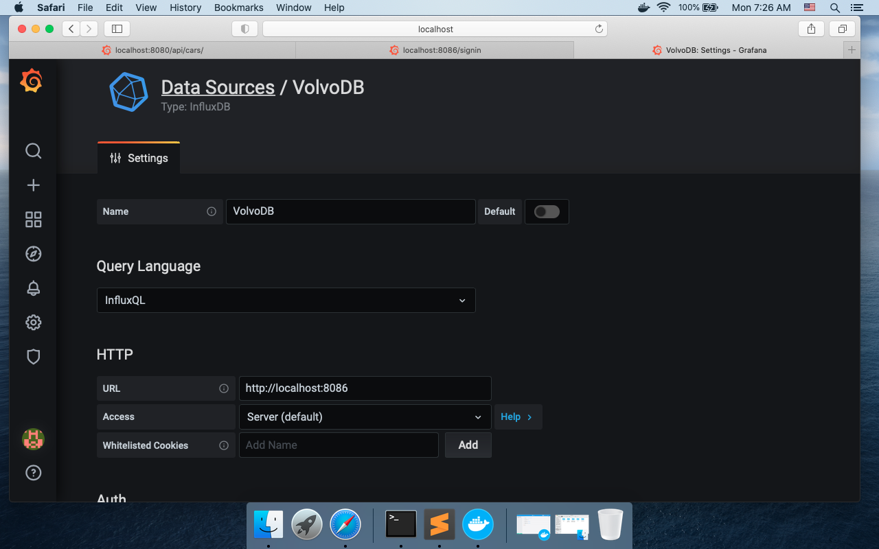

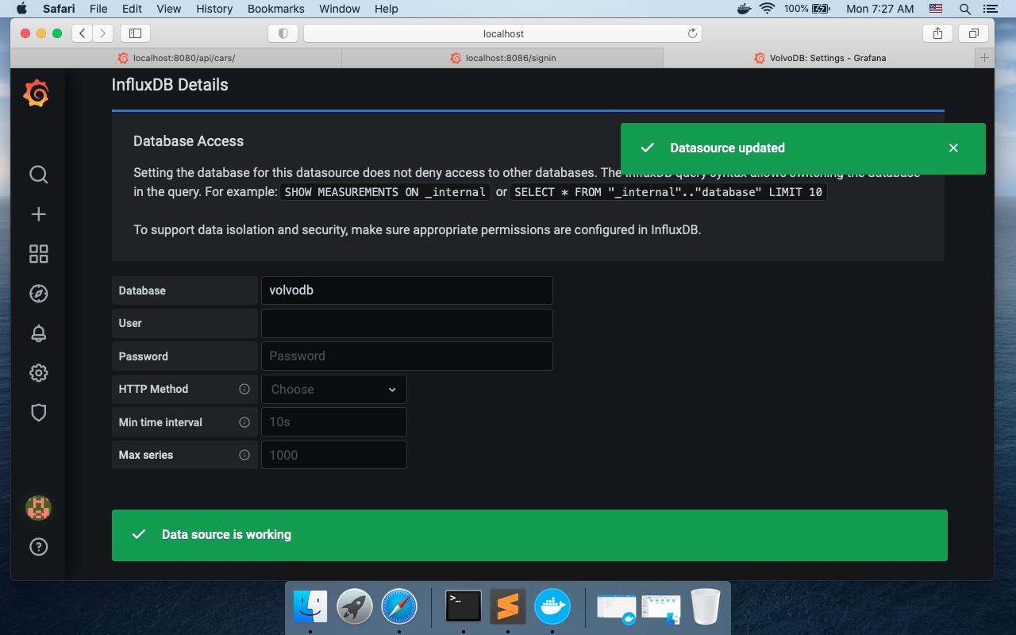

1. Execute the performance test by running the following command

“k6 run –out influxdb=http://localhost:8086/VolvoCarsDB /<script path>/script.js”

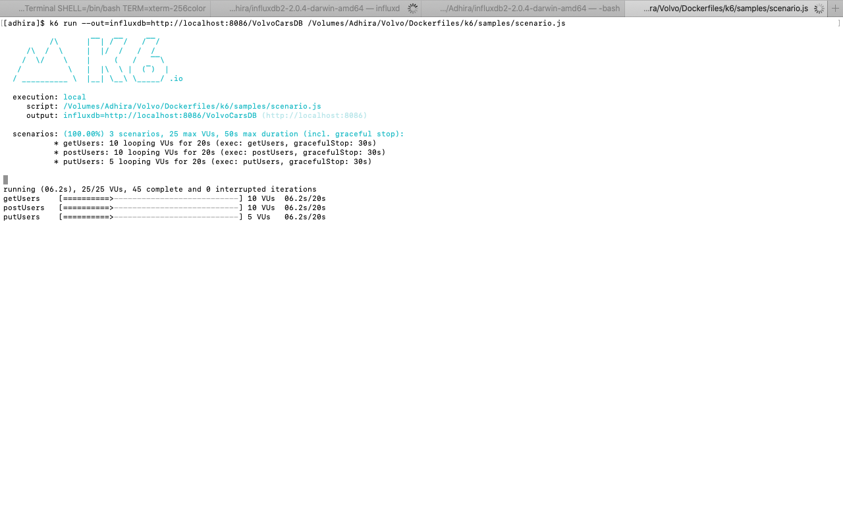

1. Open Grafana in browser and check the metrics

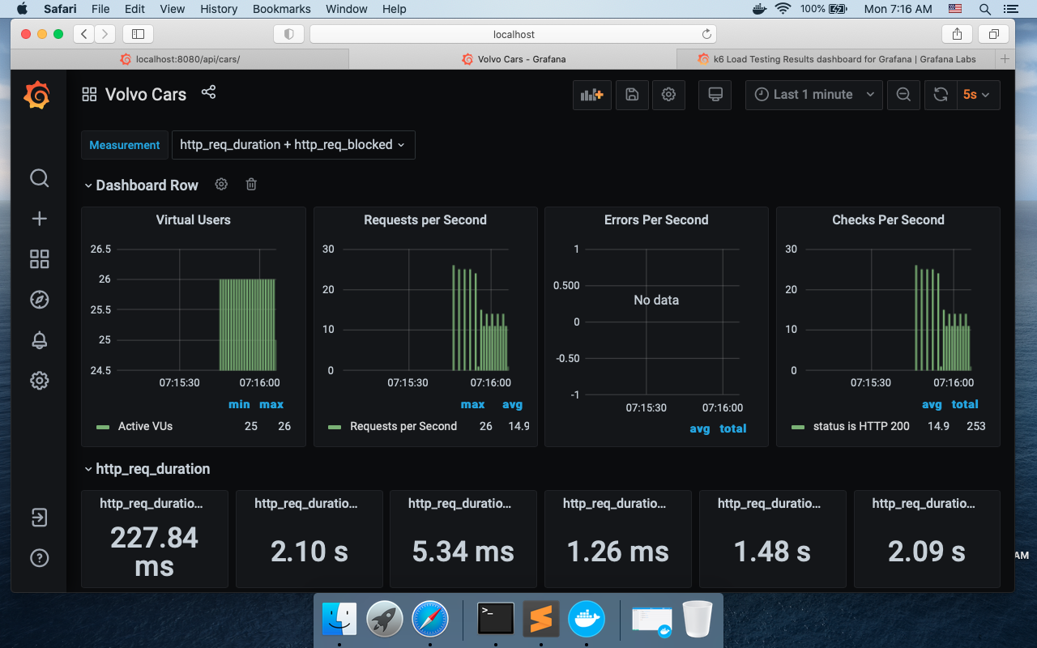

1. Screenshot of result

